

MINOR PROJECT OF WEB ANALYTICS

PROJECT REPORT

TITLE: Portfolio Website (UI/UX Dashboard using Wix)

SUBMITTED TO: SUBMITTED BY:
Mrs. PRABHJOT KAUR ROHIT GUPTA
(E17274) UID:24MCA20158

Acknowledgement

At our Web Analytics Portfolio Website, we believe that every successful digital platform is built not only with technology but also with the support and guidance of inspiring individuals.
We would like to express our heartfelt gratitude to everyone who contributed to the development and successful completion of this project. A special thanks to our respected mentor, Ms. Prabhjot Kaur, for her valuable guidance, continuous support, and insightful suggestions throughout the development of this project. Her encouragement played a key role in shaping our ideas into a successful outcome.
We are also grateful to our department and institution for providing us with the necessary resources, opportunities, and a creative learning environment that helped us enhance our technical and practical knowledge.
We extend our sincere thanks to all the teachers and faculty members whose guidance and expertise supported us throughout this journey.
Lastly, we would like to thank our friends and well-wishers who motivated and supported us during the project. Their encouragement has been a constant source of inspiration in completing this work successfully.

TABLE OF CONTENTS:

1 .Abstract 4
2 .Introduction to the Project 5
3 .Client Identification and Recognition of Need 6
4 .Problem Statement 7
5 .Objectives 8
6 .Project Identification 9-10
7 .Task Identification 11-12
8 .Software Requirement Specification 13-14
9 .SWOT and PESTEL Analysis 15
10. Literature Review 16
11 .Scope and Limitations 17
12 .Result 18-19
13 .Conclusion 20
14 .Reference 21

ABSTRACT
In today’s digital era, having a strong online presence is essential for individuals and professionals to showcase their skills and attract opportunities. Along with creating a website, it is equally important to analyze user interaction and understand website performance. This project, titled “Web Analytics Based Portfolio Website”, is developed to combine both portfolio presentation and analytics insights in a single platform.
The main aim of this project is to design a visually appealing UI/UX portfolio website while integrating web analytics features to monitor user behavior, traffic, and engagement. The website is developed using the Wix platform, which provides a flexible and user-friendly environment for creating responsive and modern web designs.
The platform includes various sections such as homepage, projects showcase, and contact details, allowing users to explore the portfolio easily. Additionally, the analytics dashboard provides insights such as visitor count, sessions, and user interaction patterns, which help in understanding the performance of the website.
This project demonstrates the importance of combining design and analytics to improve user experience and decision-making. It highlights how web analytics can play a significant role in enhancing digital platforms by providing valuable insights into user behavior.
In conclusion, the Web Analytics Portfolio Website serves as an effective solution for showcasing professional work while simultaneously analyzing website performance, making it a valuable tool in the modern digital environment.

Introduction
In the modern digital world, websites have become an essential medium for communication, professional branding, and information sharing. Portfolio websites, in particular, play a significant role in showcasing skills, projects, and achievements of individuals. However, simply designing a website is not enough; understanding how users interact with the website is equally important for improving its effectiveness.
The Web Analytics Based Portfolio Website is developed to address both aspects — presentation and analysis. This project focuses on creating a professional UI/UX portfolio website that not only displays projects but also provides insights into user behavior and website performance through analytics.
The website is designed using the Wix platform, which allows easy customization, responsive layouts, and visually appealing design elements. It includes key sections such as a homepage with an attractive banner, a projects section to showcase work, and a contact section to allow user interaction. The navigation is kept simple and user-friendly to ensure smooth browsing.
In addition to design, the project integrates web analytics features that track important metrics such as visitor count, sessions, and engagement. These analytics help in understanding how users interact with the website and identify areas for improvement.
This project highlights the importance of combining UI/UX design with data-driven insights. It not only enhances the visual appeal of the website but also improves its functionality and performance. Overall, the Web Analytics Portfolio Website serves as a modern solution for showcasing work while leveraging analytics to optimize user experience.

CLIENT IDENTIFICATION AND RECOGNITION OF NEED

Target Users
• UI/UX Designers
These users want to showcase their design skills and projects in a professional way. They look for platforms that allow them to present their work attractively and effectively to potential clients or employers.
• Recruiters and Hiring Managers
Recruiters visit portfolio websites to evaluate candidates based on their skills, projects, and creativity. They need clear project presentation, easy navigation, and quick access to important information.
• Students and Freshers
Students and beginners in the field of web development and design require a platform to display their academic and personal projects. They prefer simple, user-friendly websites that help them build their professional identity.
• Clients and Businesses
Clients look for skilled professionals by reviewing their portfolios. They expect well-organized project details, modern design, and easy contact options to connect with the developer or designer.
• General Website Visitors
These include users who visit the website to explore content, design ideas, or gain information. They expect a smooth browsing experience and visually appealing layouts.

Recognition of User Needs
• Professional Portfolio Presentation
Users need a platform where they can showcase their projects, skills, and achievements in a structured and visually appealing manner.
• Easy Navigation and Accessibility
Visitors prefer websites that are easy to navigate, with clear sections such as homepage, projects, and contact information for quick access.
• Performance and Analytics Insights
Website owners require analytics data such as visitor count, user behavior, and engagement to understand performance and improve their website.
• Responsive and Modern Design
Users expect the website to work smoothly on all devices, including mobile phones, tablets, and desktops, with a modern UI/UX design.
Traditional portfolio methods often lack proper structure, analytics tracking, and user engagement. The Web Analytics Portfolio Website addresses these issues by providing a centralized digital platform with an attractive design, smooth navigation, and integrated analytics for better performance understanding.

PROBLEM STATEMENT

Challenges in Portfolio Website and Web Analytics
• Lack of Professional Portfolio Presentation
Many individuals do not have a well-structured platform to showcase their skills and projects. Their work often remains scattered or poorly presented, making it difficult for recruiters and clients to evaluate their capabilities effectively.
• Poor User Experience
Some portfolio websites have complex navigation, cluttered layouts, and unorganized content. This creates confusion for visitors and reduces overall user satisfaction while browsing the website.
• Lack of Analytics and Performance Tracking
Most basic portfolio websites do not provide insights into user behavior, such as visitor count, page views, or engagement. Without analytics, it becomes difficult to understand how users interact with the website and where improvements are needed.
• Low User Engagement
Websites with outdated designs, poor visuals, and lack of interactive elements fail to attract and retain user interest, leading to reduced engagement and effectiveness.

Solution Provided by Web Analytics Portfolio Website
• Dedicated Portfolio Platform
The project focuses on providing a well-structured platform where users can showcase their projects and skills in an organized and professional manner.
• Clean and Organized Interface
The website is designed with a modern and simple layout, ensuring smooth navigation and an improved user experience for visitors.
• Integration of Web Analytics
Analytics features are included to track visitor data, user behavior, and engagement, helping in understanding website performance and making improvements.
• Enhanced User Interaction
Features like clear navigation, project sections, and contact forms improve user interaction and make the website more engaging and effective.

OBJECTIVE

Primary Objectives
• To develop a professional portfolio website
The main goal of this project is to create a dedicated platform where users can showcase their skills, projects, and achievements in a structured and visually appealing manner.
• To provide easy access to project information
The website aims to present all projects and details in one place, allowing visitors such as recruiters and clients to easily browse and understand the work without any confusion.
• To improve user experience through modern UI/UX design
The platform is designed with a clean layout, smooth navigation, and attractive visuals to ensure users enjoy a seamless and engaging browsing experience.

Secondary Objectives
• To promote digital presence and personal branding
The platform encourages users to build their online identity by showcasing their work through a professional portfolio website.
• To integrate web analytics features
The project includes analytics functionality to track visitor data, user behavior, and engagement, helping in understanding website performance and making improvements.
• To enhance user engagement
Interactive elements such as project sections, navigation menus, and contact forms help keep users engaged and improve their overall experience on the website.

PROJECT IDENTIFICATION

This project, titled “Web Analytics Based Portfolio Website”, is identified as a web-based platform designed to provide users with an online space where they can showcase their projects, skills, and professional work along with analyzing website performance. Unlike traditional portfolio methods, this platform operates entirely on the web, allowing users to access it anytime and from anywhere using an internet connection.
The main purpose of this project is to simplify the process of presenting portfolio content by offering a digital interface where projects, designs, and information are displayed in a well-organized and user-friendly manner. It helps users such as recruiters, clients, and visitors to explore projects, evaluate skills, and understand the work without any complexity.
Being a web-based platform, the system does not require any installation on the user’s device. It runs directly through a web browser, making it highly accessible and convenient for a wide audience. This approach removes physical limitations and allows users to access the portfolio from anywhere in the world.
The platform focuses specifically on portfolio presentation and web analytics, making it a specialized solution for designers, developers, students, and professionals who want to build their online presence and track website performance.

System Type
The system is primarily a frontend-based web platform developed using the Wix platform. This means that the main focus of the website is on user interface design, smooth navigation, and user interaction rather than complex backend operations.
Wix provides a flexible and easy-to-use environment with drag-and-drop features, allowing the creation of visually appealing and responsive web pages. This ensures that the website looks professional and functions smoothly across different devices.
The platform integrates both static and dynamic content to enhance the user experience:
• Static content includes fixed elements such as text, images, banners, and project descriptions that provide essential information about the portfolio.
• Dynamic content includes interactive elements such as project highlights, navigation menus, contact forms, and analytics sections that can be updated regularly to keep the website engaging and informative.
Since the system is frontend-focused, it emphasizes design, layout, and usability. The primary goal is to ensure that users can easily navigate the website, explore projects efficiently, and understand analytics insights in a smooth and engaging way.
The Web Analytics Portfolio Website is divided into several modules, each designed to enhance functionality and provide a smooth and engaging user experience.

Homepage (Introduction & Highlights)
The homepage serves as the main entry point of the website and creates the first impression for visitors. It features an attractive introduction, banners, and highlights of the portfolio. The purpose of the homepage is to capture user attention, provide an overview of the website, and guide users to explore different sections. It may also include key information about the developer and featured projects.

Project Showcase Section
This is the core module of the platform where various projects and works are displayed. It includes project images, titles, descriptions, and important details to help users understand each project clearly. The projects are organized in a structured manner, making it easy for visitors to browse and evaluate the work efficiently.

Analytics Dashboard Section
This section provides insights into website performance and user behavior. It may include data such as visitor count, traffic analysis, and engagement metrics. This module helps in understanding how users interact with the website and supports improvements in performance and user experience.

Navigation Bar
The navigation bar is an essential component that allows users to move easily between different sections of the website. It typically includes links such as Home, Projects, About, and Contact. A well-structured navigation bar ensures that users can quickly find the information they need, improving usability and overall satisfaction.

Footer (Contact & Information)
The footer is located at the bottom of the website and provides important details such as contact information, social links, and additional resources. It helps users connect with the website owner and builds trust. It may also include quick links and basic policies for better user support.

TASK IDENTIFICATION

Development Process of Web Analytics Portfolio Website
The development of the Web Analytics Portfolio Website involves a series of well-planned tasks that ensure the successful design, creation, and deployment of the platform. Each step plays an important role in building a user-friendly, visually appealing, and functional website. These tasks are carried out in a structured manner to achieve the overall objectives of the project.

Main Tasks Involved
1.Requirement Analysis:
Requirement analysis is the first and most important step in the development process. In this phase, the needs and expectations of users are identified and clearly defined. It includes understanding what features the website should provide, such as portfolio display, analytics insights, navigation, and user interaction elements. This step also involves analyzing the target audience like recruiters, clients, and students. Proper analysis ensures that the website is developed according to user requirements and avoids issues in later stages.
2.Designing UI/UX:
UI (User Interface) and UX (User Experience) design focus on how the website looks and how users interact with it. In this stage, the layout, color scheme, fonts, images, and overall structure are planned. The goal is to create a clean, modern, and user-friendly interface that enhances user satisfaction. A well-designed UI/UX helps users easily navigate the website and explore projects without confusion.
3.Creating Website Layout:
In this phase, the basic structure of the website is developed. It includes organizing sections such as the homepage, project showcase, analytics section, navigation bar, and footer. The layout defines how information is presented to users. A clear and well-structured layout improves readability and ensures consistency across all pages of the website.
4.Adding Projects and Content:
This step involves uploading projects along with images, descriptions, and relevant details. High-quality visuals and clear explanations help attract visitors and allow them to understand the work effectively. Projects are organized in a structured way to make browsing easy and efficient.
5.Implementing Navigation System:
The navigation system allows users to move easily between different sections of the website. It includes menus, links, and buttons that guide users to pages like Home, Projects, About, and Contact. A well-designed navigation system improves usability and ensures that users can quickly find the information they need.

6.Integrating Web Analytics:
This step includes adding analytics features to track visitor data, user behavior, and engagement. It helps in understanding how users interact with the website and provides valuable insights for improving performance and user experience.
7.Testing Website Functionality:
Testing is performed to ensure that the website works smoothly and efficiently. All features such as navigation links, responsiveness, analytics display, and content presentation are checked. Errors are identified and corrected to improve performance and reliability. This step ensures a seamless and error-free user experience.
8.Deployment:
Deployment is the final stage where the website is published and made live for users. The project is deployed using the Wix platform, making it accessible online from anywhere. This step marks the successful completion of the project and allows users to interact with the website.

SOFTWARE REQUIREMENT SPECIFICATION

Software Requirement Specification (SRS)
The Software Requirement Specification (SRS) is an important document that defines the functional and non-functional requirements of a system. It acts as a blueprint for the development of the project by clearly describing what the system should do and how it should perform. For the project “Web Analytics Based Portfolio Website”, the SRS ensures that all features are properly planned and implemented to meet user expectations.
The requirements of the system are broadly divided into two categories: Functional Requirements and Non-Functional Requirements.

Functional Requirements
Functional requirements describe the core features and operations of the system. These define what the system is expected to do.
Portfolio Display
The system should allow users to view various projects easily. Users should be able to see project images, titles, and detailed descriptions without any difficulty. This feature helps visitors understand the work and evaluate skills effectively.
Navigation System
The website should provide a clear navigation system that allows users to move between different sections such as Home, Projects, About, and Contact. This ensures easy accessibility and a smooth browsing experience.
Analytics Display
The system should include analytics features that display information such as visitor count, user engagement, and traffic insights. This helps the website owner understand user behavior and improve performance.
Contact Functionality
The website should provide a contact section or form that allows users to easily communicate with the website owner. This improves interaction and allows potential clients or recruiters to connect.
User Interaction
The system should include interactive elements such as buttons, links, and forms. These features allow users to interact smoothly with the website and enhance their overall experience.

Non-Functional Requirements
Non-functional requirements define how the system should perform and focus on quality aspects such as performance, usability, and design.
Fast Loading Speed
The website should load quickly to ensure a smooth and efficient user experience. Slow loading times can reduce user satisfaction and engagement.
Responsive Design
The website should be responsive and work properly on different devices such as desktops, tablets, and mobile phones. This ensures accessibility for all users.
User-Friendly Interface
The system should have a simple and clean interface that is easy to understand and navigate. This improves usability and user satisfaction.
Reliability
The website should function consistently without errors or crashes. All features should work properly to provide a stable user experience.
Visual Appeal
The design of the website should be modern and attractive, using proper colors, fonts, and layouts to engage users and create a professional impression.

SWOT and PESTEL Analysis
SWOT analysis is used to evaluate the internal strengths and weaknesses of the Web Analytics Portfolio Website project along with the external opportunities and threats that may affect its performance.
The strengths of this project include its modern and visually appealing user interface, which enhances user experience and keeps visitors engaged. The platform focuses on portfolio presentation and web analytics, making it easier for users such as recruiters and clients to explore projects and understand skills without confusion. Being a web-based platform, it also provides easy accessibility from anywhere at any time.
However, the project also has certain weaknesses. It is primarily frontend-based and does not include advanced backend features such as user authentication, database management, or real-time analytics processing. Additionally, the absence of a backend system limits the ability to provide highly dynamic and personalized content.
There are several opportunities available for the platform. The increasing demand for digital portfolios and personal branding creates a strong need for such solutions. The platform also has the potential to expand by integrating advanced analytics tools, backend features, and real-time data tracking. Future enhancements like user login systems, project management features, and improved analytics dashboards can significantly increase its value.
At the same time, there are some threats. The platform faces competition from existing portfolio builders and professional platforms that already offer advanced features. Additionally, rapid changes in technology and user expectations require continuous updates and improvements to stay relevant and competitive.
PESTEL analysis helps in understanding the external factors affecting the project.
Political factors include government policies related to internet usage, data privacy, and digital platforms. Economic factors involve the growth of the digital economy and increasing demand for online portfolios. Social factors highlight the growing importance of online presence, personal branding, and digital interaction. Technological factors include advancements in web development tools such as Wix and improvements in analytics technologies. Environmental factors are minimal but include the use of digital platforms reducing paper-based work. Legal factors include data protection, user privacy, and compliance with online regulations.

LITERATURE REVIEW

The literature review involves studying existing resources and platforms related to portfolio websites, web analytics, and modern web design. It helps in understanding current trends, user preferences, and best practices that can be applied to the Web Analytics Portfolio Website project.
Various portfolio platforms and personal websites were analyzed to understand their features, layout, and functionality. This analysis helped in identifying effective design strategies and areas where improvements can be made. UI/UX design principles were also studied to ensure that the website provides a smooth and user-friendly experience.
Additionally, web analytics tools and user behavior were examined to understand how visitors interact with websites and what factors influence their engagement. This includes studying metrics such as page views, session duration, and user navigation patterns.
The study revealed that users prefer simple and easy navigation, as it allows them to explore projects quickly and efficiently. It was also observed that visually appealing websites with clean layouts and high-quality images attract more users and create a strong impression. Furthermore, responsive and mobile-friendly design is essential, as a large number of users access websites through smartphones and other devices.
Overall, the literature review highlights the importance of combining effective UI/UX design with analytics insights to create a modern, user-friendly, and performance-oriented website.

SCOPE AND LIMITATIONS

The scope of the Web Analytics Portfolio Website project defines what the system is capable of doing. The platform provides an online space where users can showcase their projects, skills, and professional work. It allows visitors to browse different sections such as homepage, project showcase, analytics dashboard, and contact information, and interact with the website through various features.
The platform also focuses on improving user engagement by using attractive design elements such as banners, images, and well-structured layouts. These elements help create an engaging and informative experience for users while exploring the portfolio. Additionally, the inclusion of web analytics helps in understanding user behavior, tracking visitor activity, and improving website performance.
However, the project has certain limitations. It does not include advanced backend features such as user authentication, database integration, or real-time data processing. This means that user data cannot be stored dynamically, and analytics features are limited to basic insights. Additionally, the system does not support advanced functionalities such as user accounts, project management systems, or personalized user experiences.
Despite these limitations, the project provides a strong foundation for future enhancements. Features such as backend integration, real-time analytics, and advanced user interaction can be added to improve the overall functionality and performance of the system.

RESULT:
OUTPUTS: TOP WEBSITE PAGE:


Fig-1.1(Welcome page)

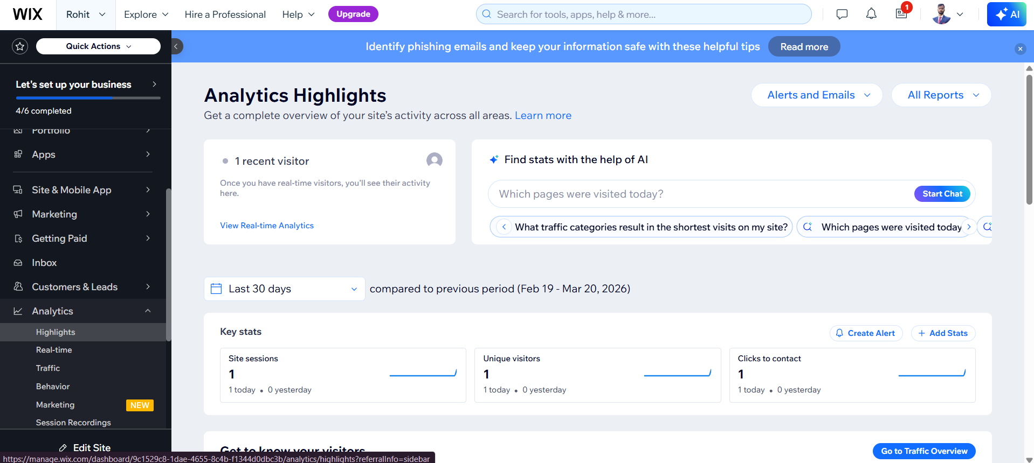

Fig-1.2(Analytics Highlight)

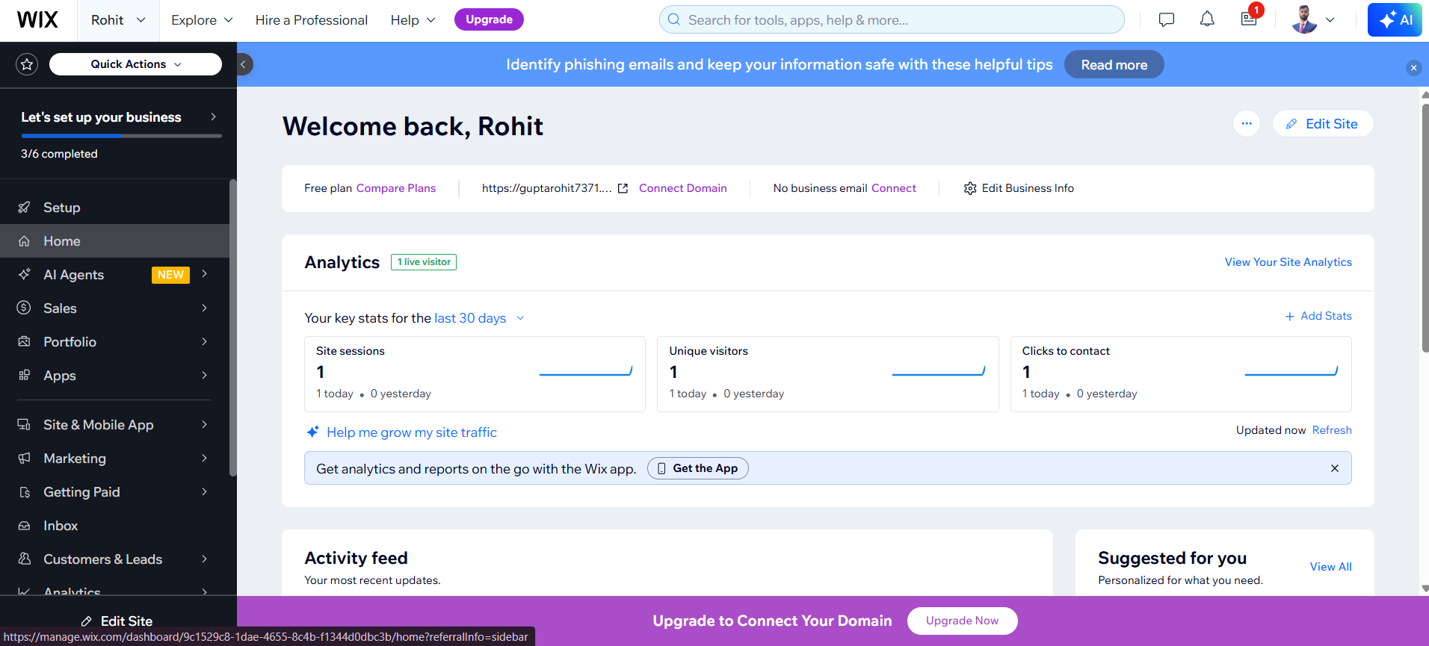
FIGURE-1.3(Analytics of Website)

CONCLUSION:

The project “Web Analytics Based Portfolio Website” successfully demonstrates the development of a web-based platform focused on showcasing professional work while analyzing website performance. In today’s digital era, where online presence plays a crucial role in personal branding and career growth, this project highlights how a well-designed website can provide accessibility, functionality, and an engaging user experience.
Throughout the development of this project, various important aspects of web development were explored, including user interface design, website layout, navigation structure, and content organization. The project emphasizes the importance of creating a visually appealing and user-friendly platform that allows users to easily explore projects and understand the skills presented. By focusing on both portfolio presentation and analytics, the platform ensures better content organization and performance understanding, which improves overall user experience.
The project also demonstrates how effective planning, task management, and execution of different phases such as requirement analysis, design, development, testing, and deployment contribute to successful project completion. Each phase played a significant role in ensuring that the final website is functional, responsive, and easy to use.
Although the project has certain limitations, such as the absence of advanced backend functionalities and real-time analytics processing, it still provides a strong foundation for future improvements. With further development, features like user authentication, database integration, advanced analytics tools, and personalized user experiences can be added to make the platform more powerful and efficient.
In addition, this project provides valuable learning experience in understanding modern web technologies, UI/UX principles, and analytics concepts. It also highlights the growing importance of combining design with data-driven insights to enhance website performance and user engagement.
In conclusion, the Web Analytics Portfolio Website is a well-structured and effective project that showcases the practical implementation of a modern portfolio platform integrated with analytics. It fulfills its objectives and opens opportunities for future enhancements, making it a strong example of a professional digital solution.

REFERENCES
References are important as they show the sources of information used during the development of the project and add credibility to the work.
Books:
- E-Commerce: Strategy, Technology and Implementation – David Whiteley
- Web Design with HTML, CSS, JavaScript and jQuery – Jon Duckett
- Electronic Commerce – Gary P. Schneider
Websites:
- https://www.wix.com
- https://www.w3schools.com
- https://developer.mozilla.org
- https://www.geeksforgeeks.org
- https://www.shopify.com/blog
Research and Articles:
Various online articles related to web analytics, UI/UX design blogs and tutorials, and studies on user behavior and digital platforms.
Tools Used:
1. Wix Website Builder
2. Web Browser (Google Chrome)
3. Internet Resources

